**Question 1**

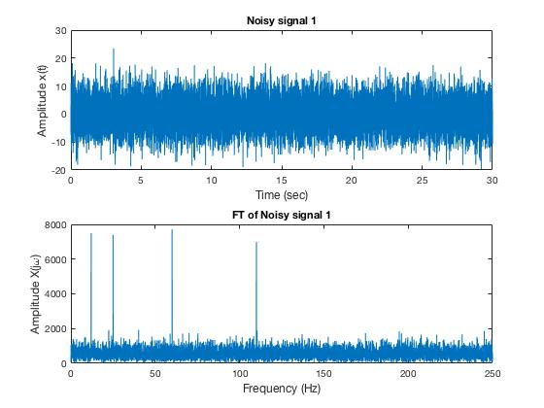

**1a**

**1b**

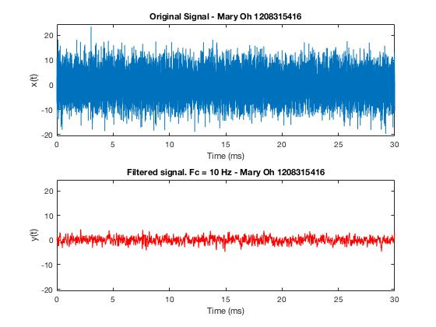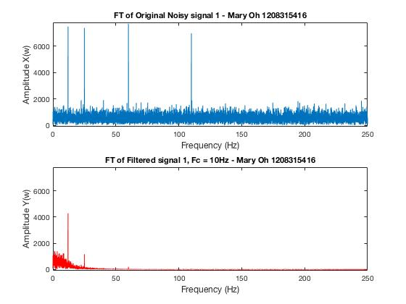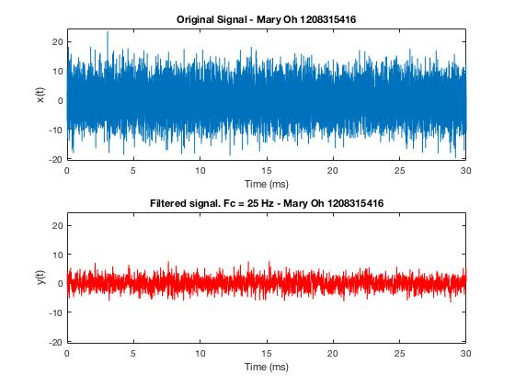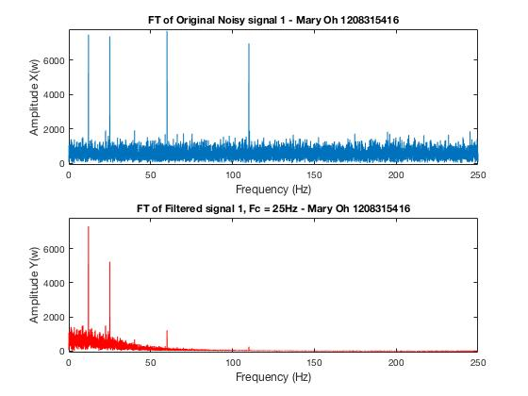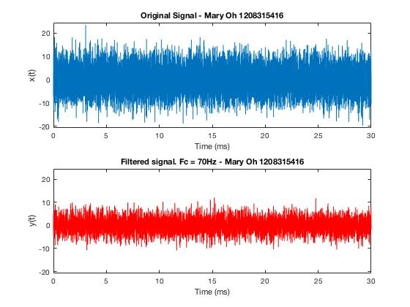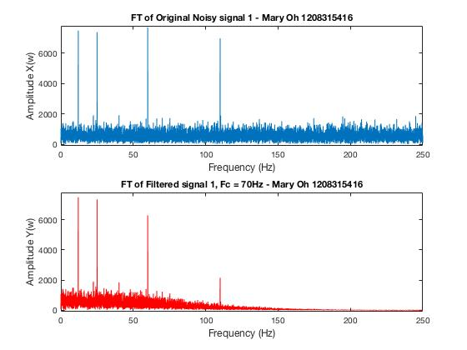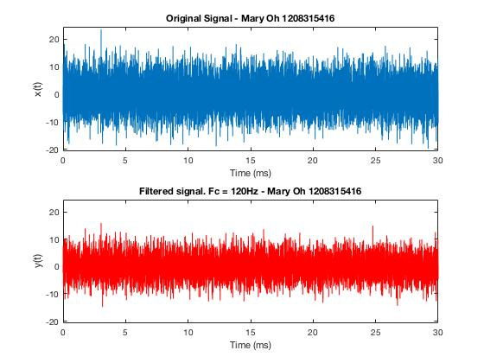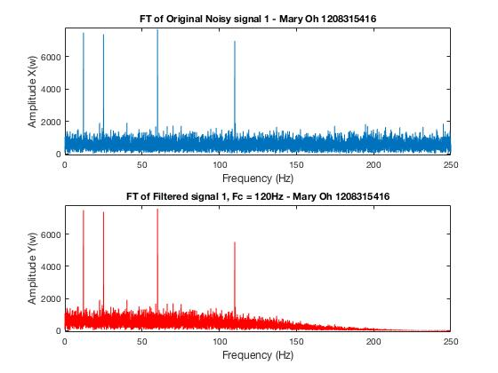

**1c**

As the cut off frequency increases, the noise on the signal as well as the amplitude increases.

**Question 2**

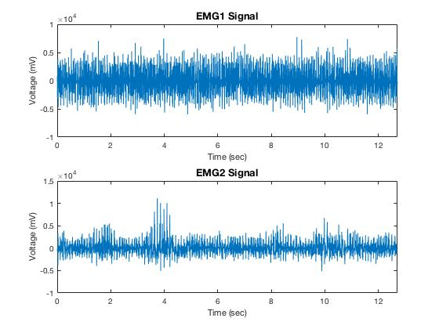

**2a**

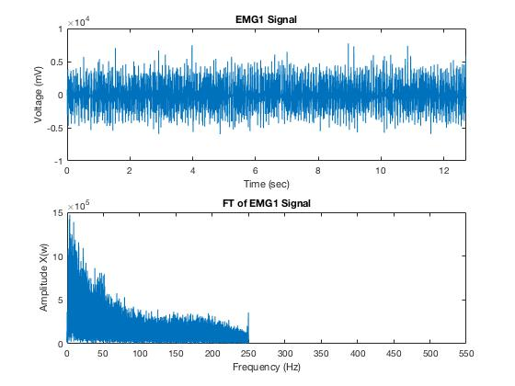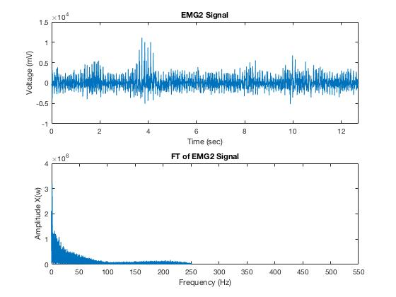

The amplitude of the frequencies is different. Also, emg1 is more noisy than emg2.

**2b**

*MNF1 =*

*2.7301e+04*

*MNF2 =*

*1.2606e+04*

**2c**

*MNF_FT1 =*

*4.9899e+03*

*MNF_FT2 =*

*2.6590e+03*

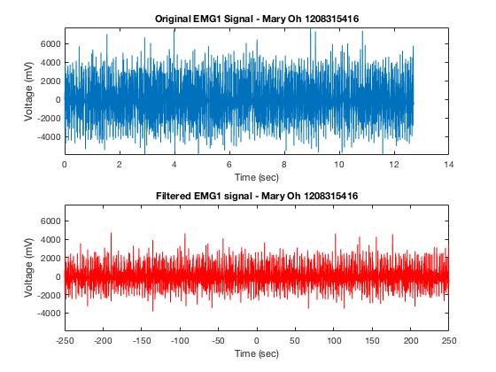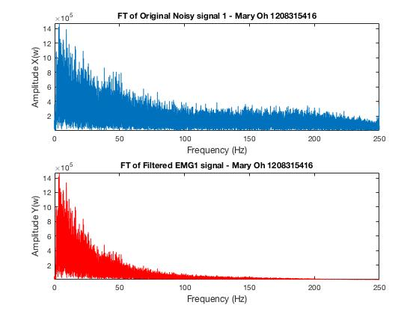

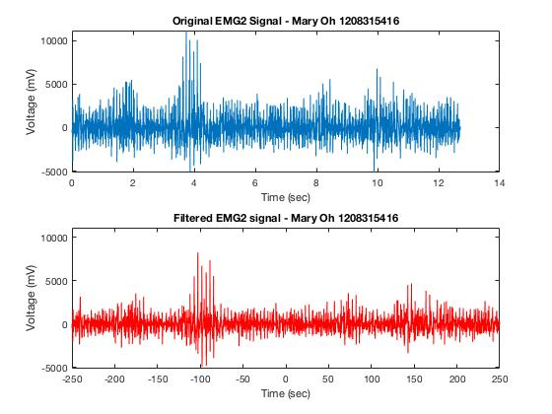

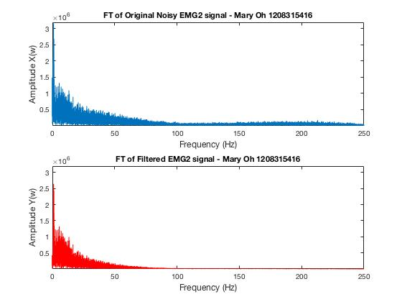

**2d**

*MNF_d11 =*

*5.9201e+03*

*MNF_d12 =*

*3.0983e+03*

*MNF_d21 =*

*6.7788e+03*

*MNF_d22 =*

*3.4931e+03*

Yes it will. MNF values are proportional to the fourier transform; hence with a change in fourier transform, MNF value will change as well.

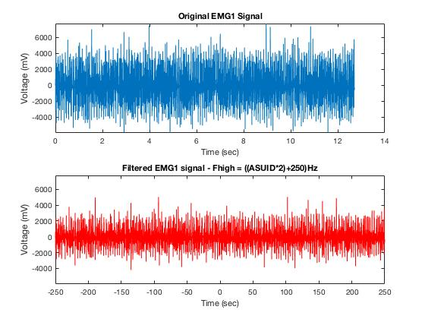

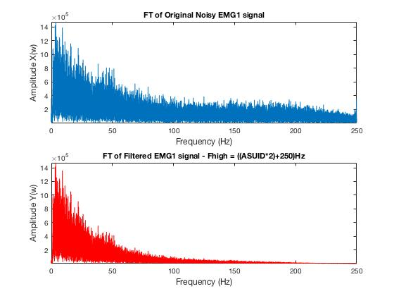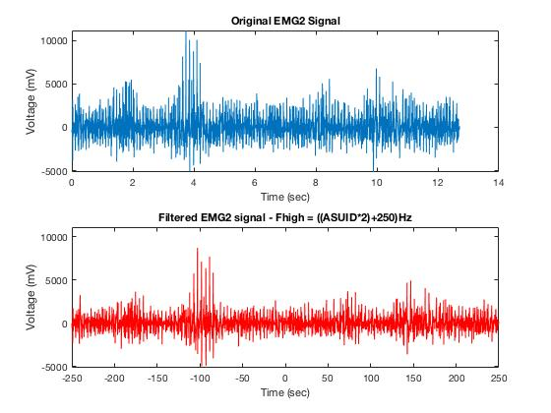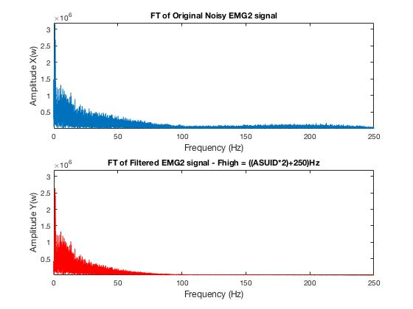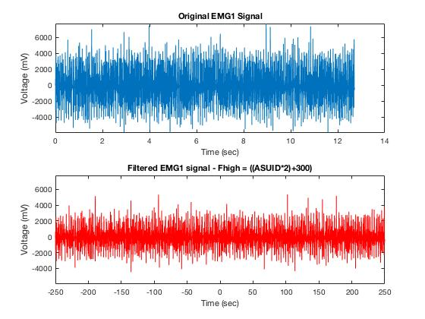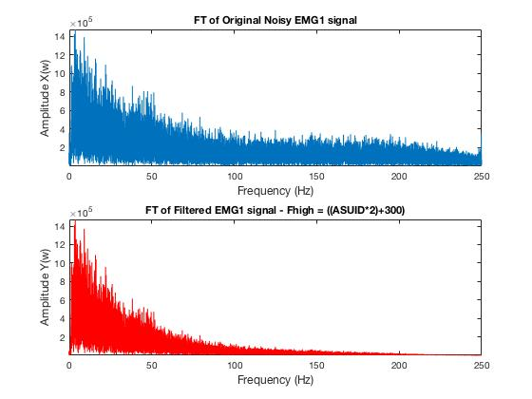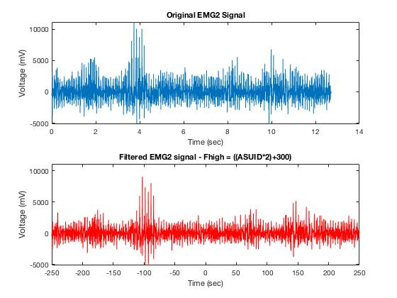

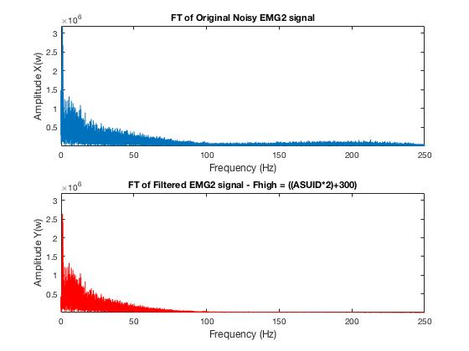

EMG1 is the signal that belongs to the subject with myopathy. Basing it on the plots, the EMG1 has more high frequencies compared to the EMG2. Also, more high frequency and less low frequency signal will result to higher MNF value; hence, EMG1 is really the signal that belongs to the subject with myopathy.